

**LA GRANDEE INTERNATIONAL COLLEGE**

**Simalchaur, Pokhara Nepal**

A Project Report

on

**"Aawas"**

**Submitted to**

LA GRANDEE International College

Bachelor of Computer Application (BCA) Program

In the partial fulfillment of the requirement for the degree of BCA affiliated to

Pokhara University

**Submitted by**

|  |  |  |  |
| --- | --- | --- | --- |
| **Name** | **Course** | **Semester** | **P.U. Registration Number** |
| Bishwas Paudel | BCA | 6th | 2021-01-53-0054 |
| Mausam Pariyar | BCA | 6th | 2021-01-53-0060 |
| Santosh Banstola | BCA | 6th | 2021-01-53-0080 |
| Sital Wagle | BCA | 6th | 2021-01-53-0081 |

**Date: 2024-07-03**

# Acknowledgement

We have presented this report focusing on the topic **''Aawas".** This report has been prepared for partial fulfilment of the requirement for degree of BCA and to have practical experience.

We are heartily thankful to the faculty of BCA, **LA Grandee International College** and our supervisor **Mr. Sunil Pandey** for his role to motivate and lead for this report. We obliged towards his constant guidance , supervision and feedbacks which enabled us to prepare a well-executed report.

Further, we express our gratitude to LA Grandee family, classmates, seniors and teachers who have directly and indirectly supported us during our report.

Sincerely,

Bishwas Poudel

Mausam Pariyar

Santosh Banstola

Sital Wagle

# Student's Declarations

**"Aawas"**

We hereby declare that we are the only authors of this work and that no sources other than the mentioned here we have been used in this .We assure you that the work we present here is unique to ourselves and resemblances to another similar project are purely coincidental.

……………………….

**Bishwas Paudel (2021-1-53-0054)**

……………………….

**Mausam Pariyar(2021-01-53-0060)**

………………………..

**Santosh Banstola (2021-1-53-0080)**

………………………..

**Sital Wagle (2021-1-53-0084)**

Program: BCA 6th Semester

Date: 2024-07-03

# Supervisor's Declaration

I hereby declare that the project entitled **“Aawas”** has been carried out under my direct supervision by **Bishwas Paudel, Mausam Pariyar, Santosh Banstola, and Sital Wagle,** during their sixth semester for the partial fulfilment of the requirements for the degree of BCA program under Pokhara University.

**_______________**

**Mr. Sunil Pandey**

(Project Supervisor)

Date: 2024-07-03



Date: 2024-07-03

…………………………..

**Er. Kiran K.C**

Principal

…………………………..

**Mr. Ramesh Chalise**

Department Coordinator

………………………………….

**Er. Santosh Panta**

External Examiner

…………………………..

**Mr. Sunil Pandey**

Supervisor

# Letter of Approval

We certify that we have examined this report entitled “**Aawas**” and are satisfied with the project defense. It is satisfactory in the scope and qualify as project in partial fulfillment of the requirements for the degree of BCA under Pokhara University.

# Abstract

Science and Technology has changed this world into a small, secure, and easy-to-manage activity for individuals and organizations. The internet is a great attraction for users’ attention as well as a great interaction channel for connection renters and landlords. Thus, the use of the “Aawas System” is a web-based platform needed to manage, search and book the housing system easily. In order to give easy access to find the rooms/flats and select no. of rooms as per the renter's need and to upload the location, contact no., expected rent, no. of rooms, facilities, and other information by the tenant, the web application has been developed in this documentation. It will take so much time for people to find their rentals. To solve this problem, we need a platform to help people find a house. The owner can also promote their house on the platform to attract the people. The system will find the nearby house rental that is available and it will make comparisons with other houses for the student to make their choice according to the features requirement.

Keywords:

Aawas System, PHP, Mysql, Rental, Owners, Property.

Table of Contents

Acknowledgement ii

Student's Declarations iii

Supervisor's Declaration iv

Letter of Approval v

Abstract vi

List of Figures ix

List of Tables x

Abbreviations xi

1. Introduction 1

2. Problem Statement 2

3. Objectives 3

4. Background Study 4

5. System Design 6

5.1. Methodology 6

5.1.1. Block Diagram 7

5.1.2. Flowchart 8

5.1.3. Data Flow Diagram 9

5.1.4. ER Diagram 12

5.1.5. Use Case Diagram 13

5.1.6. Database Diagram 14

6. Testing 15

6.1. Test Objectives 15

6.2. Test Results 15

7. Project Result 17

8. Future Enhancements 20

9. Conclusion 21

10. Annex 22

11. References 25

# List of Figures

Figure 5.1.1: Block Diagram 7

Figure 5.1.2: Flowchart 8

Figure 5.1.3: Data Flow Diagram 9

Figure 5.1.4: ER Diagram 12

Figure 5.1.5: Use Case Diagram 13

Figure 5.1.6: Database Diagram 14

Figure 10.1: Landing Page 22

Figure 10.2: Landing Page 23

Figure 10.3: Login Page 23

Figure 10.4: Rental Page 24

# List of Tables

Table 6.2: Test Results 15

# Abbreviations

|  |  |
| --- | --- |
| API | Application Programming Interface |
| BCA | Bachelor of Computer Application |
| DFD | Data Flow Diagram |
| ERD | Entity Relationship Diagram |
| IT | Information Technology |
| PU | Pokhara University |
| UI | User Interface |

# 1. Introduction

Aawas: Your One-Stop Solution for Comfortable Living

Finding the perfect place to live can be a daunting task, but Aawas is here to change that. Whether you’re a student, a professional, a traveler, or part of a family, Aawas offers a wide range of accommodation options to suit your needs. From individual rooms to apartments and shared spaces, we provide cost-effective and affordable alternatives for everyone.

Navigating through Aawas is a breeze thanks to our user-friendly interface. Our smart search filters make it easy to find exactly what you’re looking for based on location, price, amenities, and accommodation types. With real-time updates, you can be confident that you’re always seeing the latest available options, eliminating the frustration of outdated listings.

Communication is key, and our secure messaging feature allows direct interaction between users and landlords. This streamlines inquiries and booking processes, making the entire experience hassle-free. Gone are the days of manually searching for rooms and apartments; Aawas simplifies the process, helping you find the perfect home effortlessly.

Aawas is more than just a web-based application; it’s a platform designed to meet your specific needs. Landlords can easily advertise their vacant spaces, while users can filter their requirements to find the ideal household for themselves, their families, or even a commercial space for a new office setup. You can analyze room rates and secure the best deals, all under our motto: “Secure Your Comfort Living.”

Transparency and convenience are at the heart of Aawas. We strive to make it easy for users to find their dream accommodation and for landlords to find the right tenants. Our ultimate goal is to save valuable time for both seekers and renters. With just a few clicks on our website, you can find a place to live or list a space for rent, all with complete confidence and ease.

# 2. Problem Statement

In today's fast-paced world, finding a place to stay can be a big problem for students, workers, and other people. The current websites and apps for finding accommodation aren't always easy to use, not reliable and don't provide the transparent and detailed information of the space.

* The contemporary issue regarding the renting business is that people still don’t rely on the modern approaches like websites, social media etc. as there’ve been a lot of scams and foul play in such path.
* People go manually door to door to get a perfect space to live in which obviously a time is consuming process.
* Further, Users often struggle to find what they're looking for among a large no of listings, and sometimes the information is old or out-of-date.
* The landlords are also not able to advertise their vacant space which is open for renting.
* There seems a communication and marketing gap in market regardless the landlord’s willingness to let and seekers willingness to find a room.

Because of these problems, people waste a lot of time and effort searching for a place to live, and they might end up feeling unsure about their choices. What's needed is a new platform that's easy to use and puts users' needs first. This platform should keep information up-to-date in real-time and make it easy for users to communicate with property owners. With a better system in place, people can find the perfect place to live quickly and confidently.

# 3. Objectives

The key objective of the Aawas is:

* To save valuable time of users i.e., both seeker and renter through providing rooms according to the requirements and allowing advertisement of vacant space respectively.

# 4. Background Study

In today's rapidly evolving world, securing a suitable place to live has become an increasingly complex task. Traditional methods of finding accommodation often prove to be inefficient, frustrating, and time-consuming. This issue is particularly pressing for students, professionals, travelers, and families who require reliable and accessible housing solutions. Conventional approaches, such as manually searching for properties or relying on word-of-mouth, fail to meet the demands of a fast-paced lifestyle and the need for up-to-date information.

Despite the rise of online platforms aimed at simplifying the search for accommodation, many existing websites and applications fall short in terms of user-friendliness, reliability, and transparency. Users frequently encounter outdated listings, incomplete property details, and unreliable communication channels, leading to mistrust and reluctance to use these modern tools. Additionally, the prevalence of scams and fraudulent activities on these platforms further exacerbates the issue, discouraging both seekers and landlords from fully embracing digital solutions.

Aawas was conceived to address these challenges and revolutionize the way people find and rent accommodation. Recognizing the gaps in the current market, Aawas offers a comprehensive, user-friendly web-based platform designed to bridge the communication and marketing gap between renters and landlords. By researching in real world market, we came to know that several sites like Gharbeti.com, pokhararoomrental.com, roomfinder.com etc. have also facilitating room rental services. However, we found some drawbacks on these sites like real time listing of properties, inefficient communication within the site and so on. By providing a diverse range of listings—from individual rooms to apartments and shared spaces—Aawas caters to the unique needs of various users, ensuring cost-effective and affordable housing options.

The platform’s intuitive interface and advanced search filters allow users to quickly and efficiently find properties based on their specific requirements, such as location, price, amenities, and accommodation type. Real-time updates ensure that users have access to the latest available options, eliminating the frustration of outdated information. Furthermore, Aawas prioritizes secure communication between users and landlords through its integrated messaging feature, streamlining the inquiry and booking processes.

Aawas aims to save valuable time for both seekers and landlords. Landlords can easily advertise their vacant spaces, while users can confidently search for their ideal homes or commercial spaces. The ultimate goal of Aawas is to provide a seamless and trustworthy platform that enhances the rental experience, ensuring that finding a place to live is no longer a source of stress, but rather a straightforward and secure process.

# 5. System Design

## **5.1. Methodology**

For the development of Aawas site we use the iterative model. Iterative model is one of the popular models for development of projects. Iterative model starts with a simple implementation of a subset of the software requirements and iteratively enhances the evolving versions until the full system in implemented.

* Inside Problem Identification Phase, the main problem that we discovered is that there is a communication and marketing gap among the seekers and the landlords and further, there is not enough advertisement of vacant spaces.
* During Problem analysis phase, we come to know some requirements regarding the development of the system. They are presented below:
  + To showcase different spaces with detailed information such as locations, Price, availability date etc. which create ease to user to find an optimum option.
  + To have a well-Managed database for user records.
  + To be dynamic to address certain changes in the information.
* In Requirement analysis phase, we will do feasibility analysis for the system based on the requirements mentioned above. Some of the feasibility analyses that we will do are:
  + Technical Feasibility Analysis
  + Operational Feasibility Analysis
  + Economic Feasibility Analysis
* In the system design phase, we will use system design tools like DFD, E-R diagram, and flowchart and build a conceptual model of the system.
* After making a conceptual model, actual coding for the system will take place
* System testing and debugging is done when required.

System Implementation takes place after the system is tested and ready to use, we will provide further maintenance for improvements and updates with emergency maintenance.

### **5.1.1. Block Diagram**

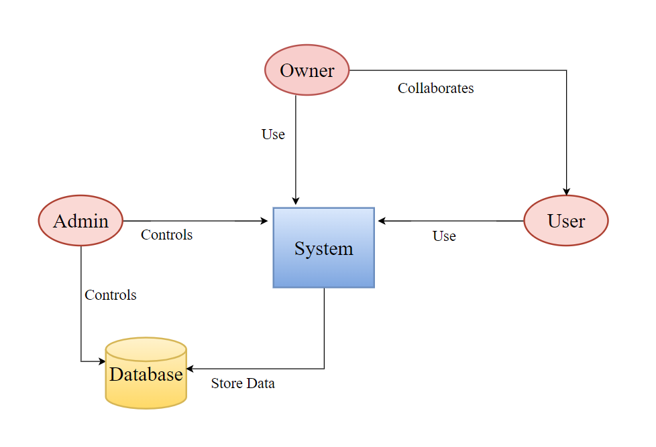

Figure 5.1.1: Block Diagram

### **5.1.2. Flowchart**

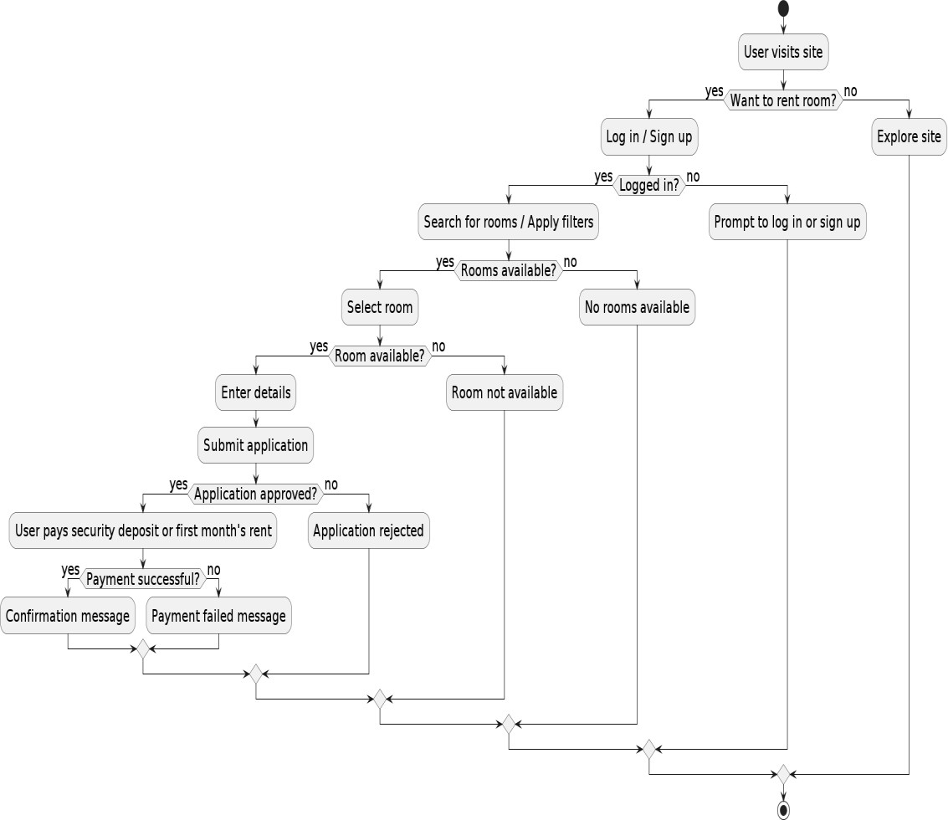Flowchart of the suggested Aawas is provided below:

Figure 5.1.2: Flowchart

### **5.1.3. Data Flow Diagram**

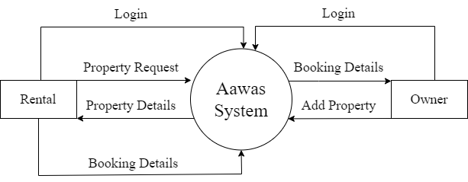

Figure 5.1.3: Level 0

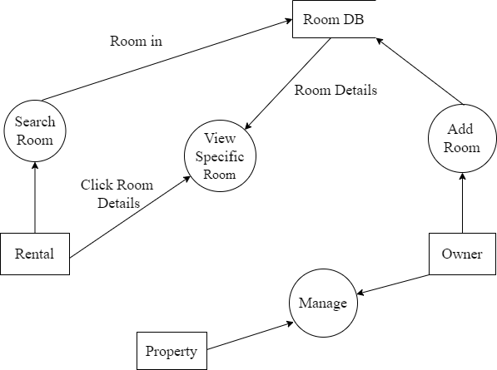

Figure 5.1.3: Level 1

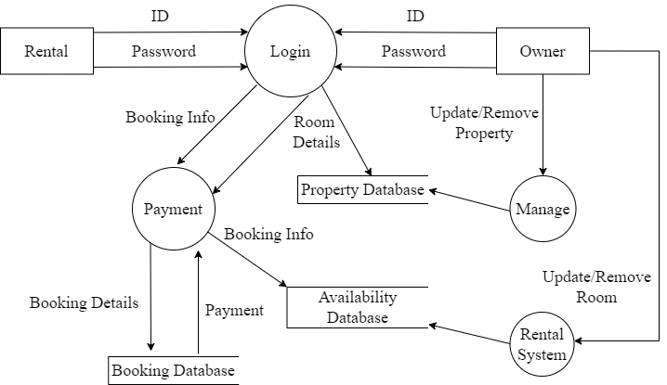

Figure 5.1.3: Level 2

### **5.1.4. ER Diagram**

An Entity Relationship Diagram (ERD) is a visual representation of different entities within a system and how they relate to each other.

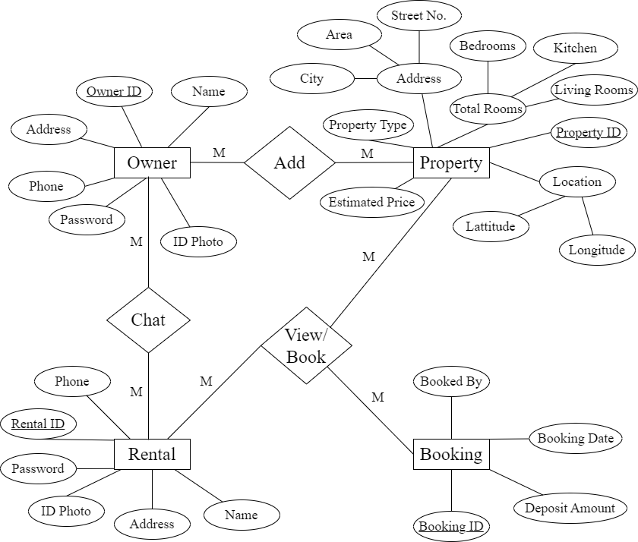

Figure 5.1.4: ER Diagram

### **5.1.5. Use Case Diagram**

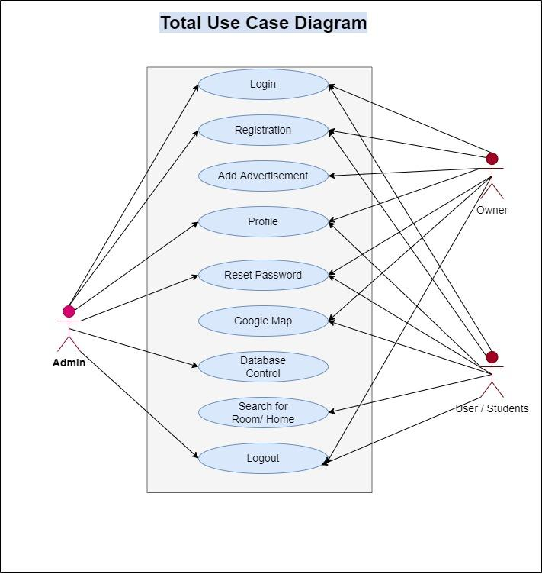

Figure 5.1.5: Use Case Diagram

### **5.1.6. Database Diagram**

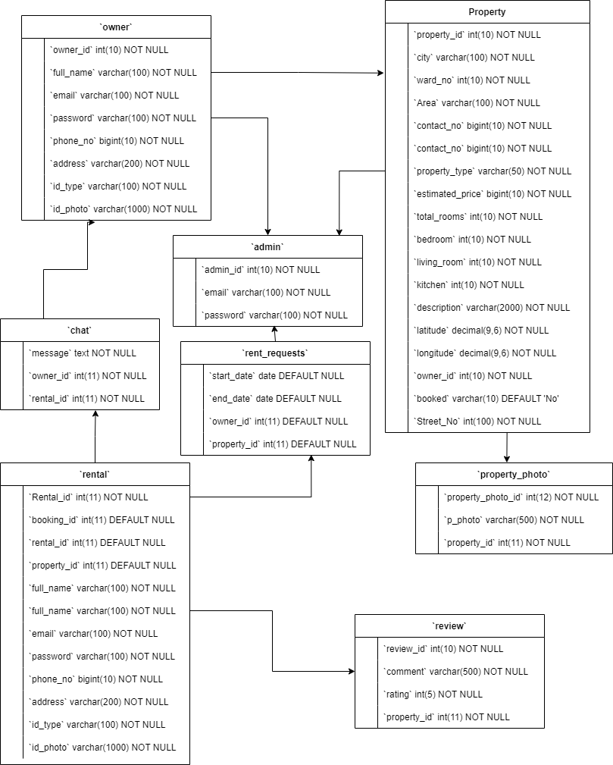

Figure 5.1.5: Database Diagram

# 6. Testing

## **6.1. Test Objectives**

* The main objectives of testing Online Home Rental were:
* To check whether the Web Application is built per the set objectives
* To ensure errors get fixed before deployment.
* To gain confidence in the level of quality of the system.

## **6.2. Test Results**

|  |  |  |  |  |
| --- | --- | --- | --- | --- |
| SN. | Test Cases | Expected | Observed | Results |
| 1. | Authentication for the user and Home/Apartment/Room Owner. | Customer and owner with the correct email and password can login. | Only specific emails with its respective correct password were logged in. | OK |
| 2. | Register the properties. | Owner authenticated can only view details and book the time for specific time. | Only authenticated Owner was able to register their property. | OK |
| 3. | Search the properties for non-register user using different keywords. | Anyone around the globe can access the webapp and search for the property in desired location. | Everyone was able to search property within certain location using different keywords. | OK |
| 4. | Property Details Viewing | All users can view detailed information of listed properties. | All users were able to view all details of properties. | OK |
| 5. | Property Booking | Users can book a property for a specified time period. | Only authenticated users were able to book properties. | OK |
| 6. | User Profile Management | Users can update their personal information and preferences. | Authenticated users were able to update their profiles. | OK |
| 7. | Search Filters Functionality | Users can filter search results by location, price, amenities, and type of accommodation. | Search filters correctly refined the property listings. | OK |
| 8. | Payment Gateway Integration | Users can make payments for bookings through integrated payment gateways. | Payments were processed successfully and securely. | OK |
| 9. | Real-time Property Availability | Users see the latest property availability updates in real-time. | Real-time updates reflected the correct availability status. | OK |
| 10. | User Reviews and Ratings | Users can leave reviews and ratings for properties and landlords. | Reviews and ratings were submitted and displayed correctly. | OK |

# 7. Project Result

Aawas has successfully met its goals of providing a reliable, efficient, and user-friendly platform for finding and renting accommodation. The project's achievements demonstrate a significant improvement in addressing the common challenges faced by both seekers and landlords in the rental market.

**What are the functions achieved by our project?**

1. User-Friendly Interface:

* Developed a highly intuitive and easy-to-navigate interface for both seekers and landlords.
* Integrated smart search filters to allow precise matching based on location, price, amenities, and accommodation types.

2. Real-Time Updates:

* Implemented a real-time update system to ensure that users always see the latest available options.
* This feature helps in eliminating outdated listings, ensuring accurate and current information.

3. Comprehensive Listings:

* Created a platform offering diverse accommodation options, from individual rooms and shared spaces to entire apartments and commercial spaces.
* Enabled landlords to easily advertise their vacant spaces.

4. Transparency and Convenience:

* Prioritized transparency in listings and transactions, allowing users to make informed decisions.
* Ensured convenience for both users and landlords, saving valuable time and effort.

**What problems have been solved by the project?**

1. Trust and Reliability:

* Addressed the lack of trust in modern approaches like websites and social media by providing a secure and transparent platform.
* Mitigated the risk of scams and foul play commonly associated with online rental services.

2. Manual Searching:

* Eliminated the need for manual door-to-door searching for accommodation.
* Simplified the process of finding a perfect home or office space through an efficient and centralized platform.

3. Outdated Information:

* Solved the issue of outdated information by providing real-time updates.
* Ensured that users always have access to the most current listings.

4. Communication Gap:

* Bridged the communication gap between landlords and seekers.
* Facilitated direct and secure communication, enhancing the overall user experience.

**What requirements have been met?**

1. Ease of Use:

* Developed a platform that is easy to use for both seekers and landlords.
* Provided features that cater to the specific needs of various user groups, including students, professionals, travelers, and families.

2. Efficient Search and Booking:

* Implemented smart search filters to allow users to find exactly what they’re looking for.
* Streamlined the booking process through secure messaging and real-time updates.

3. Diverse Accommodation Options:

* Ensured a wide range of accommodation options are available, catering to different preferences and requirements.
* Supported various types of listings, including individual rooms, shared spaces, apartments, and commercial spaces.

4. Time-Saving:

* Achieved the objective of saving valuable time for both seekers and renters.
* Provided a quick and efficient way to find or list accommodation, reducing the time and effort traditionally associated with these tasks.

# 8. Future Enhancements

Some of the improvements that can be implemented in the future are as follows:

* Better user Interface.
* More information about Rentals and more precise location searching.
* Improved security and system.
* Real time chat system for interaction between users.
* Implementation of room sharing features.
* Property listing validation through the manual approval of admin.

# 9. Conclusion

Aawas is designed to revolutionize the way people find and rent accommodation, addressing the common challenges and inefficiencies in the current market. We understand the frustration that comes with shifting through outdated listings and dealing with unreliable information. Our platform offers a user-friendly experience, with smart search filters and real-time updates that ensure you always have access to the latest and most relevant options.

With Aawas, communication between users and landlords is seamless and secure, making inquiries and bookings straightforward and hassle-free. Our goal is to provide a transparent and convenient solution that saves time for both seekers and renters. Whether you're a student, a professional, a traveler, or part of a family, Aawas is here to help you find the perfect place to live quickly and confidently. Embrace the ease of finding your dream home with Aawas, where securing your comfort living is just a few clicks away.

# 10. Annex

Aawas, this web app is built with the feature such as rental account management, admin account functionality and owner functionality, we successfully achieved several key milestones. The web app has a user-friendly interface with smart search filters that make it easy to find exactly what you're looking for based on location, price, amenities, and accommodation types. With real-time updates, you can be confident that you're always seeing the latest available options.

Overall, these achievements have significantly addressed the common issues of outdated information, lack of transparency, and inefficient communication between landlords and renters, thus providing a secure, user-friendly platform for all users.

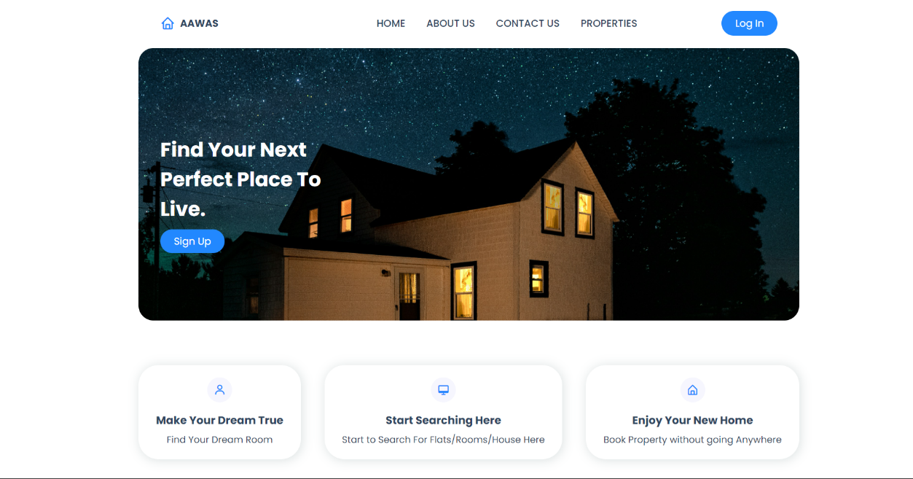

Figure 10.1: Landing Page

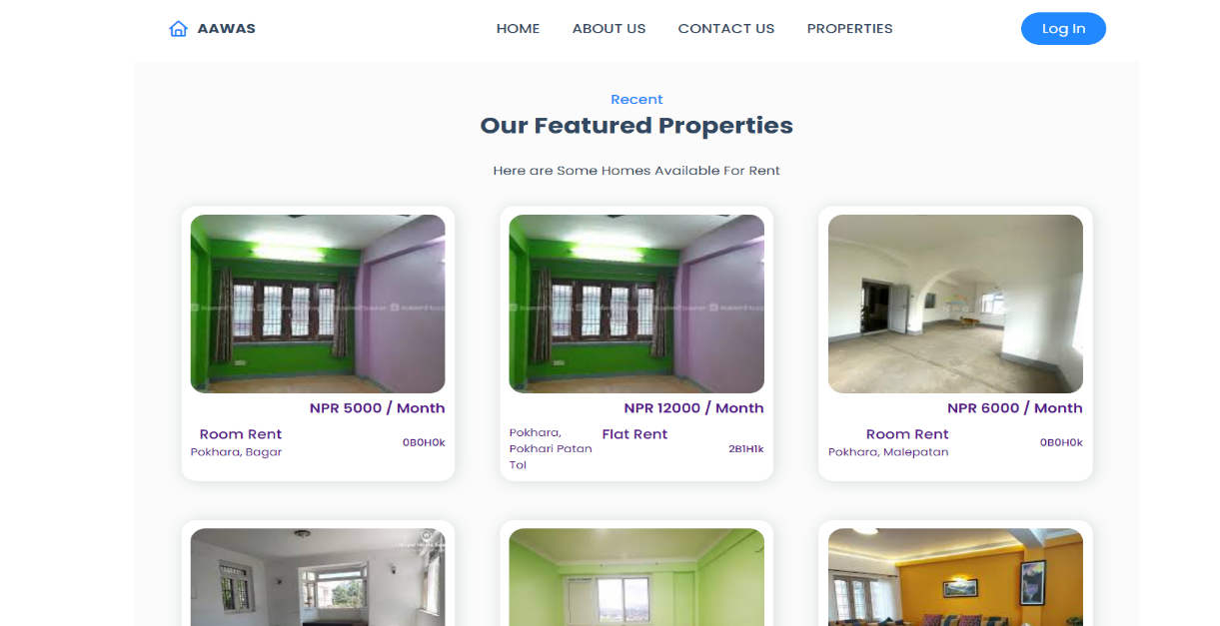

Figure 10.2: Landing Page

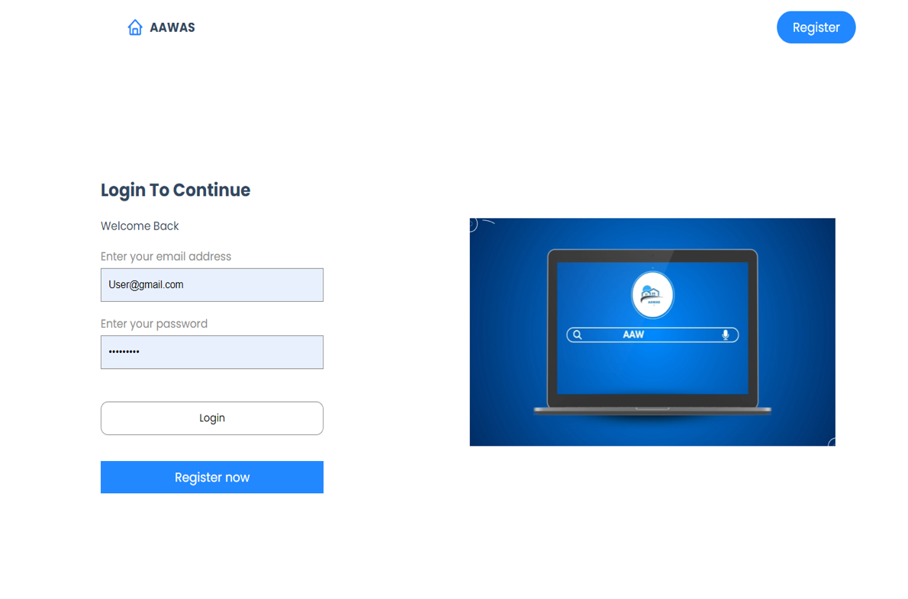

Figure 10.3: Login Page

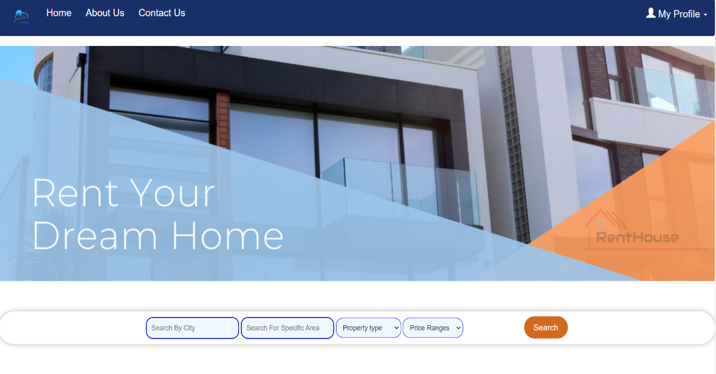

Figure 10.4: Rental Page

# 11. References

Find Properties, H. f. (n.d.). Retrieved from GharBheti: https://gharbheti.com

Easyfinderapp. (n.d.). *Focus on what’s important and spend less on rent.*

Roomfinder. https://roomfinderapp.com/

Rental, P. (2020, January 15). *Want to rent flat in Pokhara?* Retrieved from Pokhara Rental:

<https://pokhararental.com/>

Sapkota, A. (2021, September 23). Retrieved from Mero Ghar: https://[www.scribd.com/document/527006369/MeroGhar](http://www.scribd.com/document/527006369/MeroGhar)

Xettri, S.(2022,June 7). Retrieved from Github:

<https://github.com/Soul-Xettri/RoomRentalSimplePhp>

Voumik, D., Deb, P., Sutradhar, S., & Khan, M. M. (2021, July 8).

*Development of online based Smart House renting web application*.

Journal of Software Engineering and Applications. Retrieved June 14, 2022, from

https://www.scirp.org/journal/paperinformation.aspx?paperid=110723